Division of Environmental Health

Lodging Plan Review Application/New Permit Application

Name of Facility: Phone #:
Physical Address of Facility:
City: State: Zip Code:
Owner of Facility: Phone #:

Mailing Address of Facility:
City: State: Zip Code:
Applicant /Contact Person: Phone #:
Applicant Email Address:
Relation to owner (mark one): Architect □ Owner □ Employee □ Contractor □ Other □
Commercial Plan Project Number (if applicable):

FACILITY INFORMATION TO BE COMPLETED BY APPLICANT

Type of lodging establishment: □Hotel/Motel □Bed and Breakfast Home (up to 8 rooms) □Bed and Breakfast Inn (up to 12 rooms)
Construction type: □New □Remodel Existing Structure □Change of Ownership
Scope of work:

Sewage Disposal: □ Municipal □Septic Tank
Water Supply: □ Municipal □ Well

Proposed operating days and hours:
Proposed date that facility will open:
Number of guest rooms requesting approval for:

Type of hotel/motel room rentals: □ Daily □ Extended Stay*

*Extended stay rooms located in the same building as daily rentals will be subject to permitting and inspection.

Continental Breakfast □Yes □No

A separate Food Service Application must be submitted if food is to be served on site. This does not apply to continental breakfast or meals at bed and breakfast facilities.

APPLICANT /OWNER/DIRECT OR MUST SIGN APPLICATION

Applicant NAME & TITLE: Signature

Date

If this is a new facility being constructed: Submit a complete set of Architectural Plans (scale: ¼”=1 foot)
SUMBIT THIS APPLICATION WITH PLANS
visit: https:ehs.ncpublichealth.com/rules.htm to view all sanitation regulations

The Environmental Health Division can be reached from 8:00am to 5:00pm Monday-Friday at 910-433-3618
LODGING ESTABLISHMENTS (INCLUDING BB HOMES AND INNS)
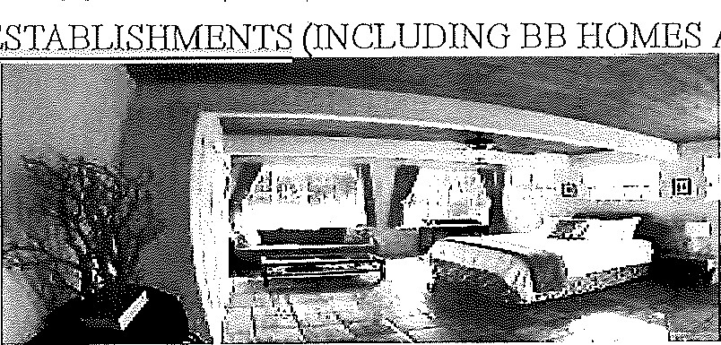

Lodging establishments include all hotels, motels, inns, bed and breakfast homes, bed and breakfast inns and other places providing lodging accommodations for pay. Inspections are performed once per year for Bed and Breakfast Homes and twice per year for hotels/motels and Bed and Breakfast Inns. Each facility with a grade posted of either A, B, or C.
Inspections are performed to ensure the proper sanitation of the establishment inspected. During an inspection, the Environmental Health Specialist will check for a number of items. These include, but are not limited to, room condition and cleanliness and proper lighting, cleanliness of ice buckets, pest presence, and proper waste disposal and furniture condition. In addition, for those establishments providing a continental breakfast, we ensure that the proper food safety guidelines are being followed and that establishments that are preparing food have a food service permit as governed by Rules Governing The Food Protection and Sanitation of Food Establishments J5A NCAE 18 A .2600 and the 2009 Food Code
NEW Bed and Breakfast Rules to combine with Lodging Rules
The NC Department of Health and Human Services Food Protection Branch issued the New Rules Governing the Sanitation of Lodging Establishments. These rules were effective as of October 1, 2017. The Rules Governing the Sanitation of Bed and Breakfast Homes, the Rules Governing the Sanitation of Bed and Breakfast Inns, and the Rules Governing the Sanitation of Lodging Establishments have been repealed and are now included in the new Rules Governing the Sanitation of Lodging Establishments. In other words, three sets of rules have been combined in to one set. The Inspection of Lodging Establishment form will be used for all lodging inspections, including bed and breakfast homes and bed and breakfast inns.

Lodging Application (Includes BB Homes and Inns)
New Lodging Rules
New Lodging Rules Changes Fact Sheet
Continental Breakfast Guidance
Loading Cleaning Guidance - English
Lodging Cleaning Guidance - Spanish
Lodging In Housekeep in Can Guidance -English Lodging In Housekeeping Cart Guidance – Spanish

NEW LODGING RULES
Cumberland County Public Health Department
October 1, 2017

Significant Changes in the New Lodging Rules
- New Format containing NC Food Code References

- There are 41 new defined terms in Rule .1821

- BB Homes and Inns will be required to have a Certified Food Protection Manager by October 1, 2018

- Chapter 3 of the NC Food Code applies to all BB Homes and Inns.

- Rule .1824 requires testing method for sanitizers used on food contact surfaces.

- Rule .1825 references Chapter 5 of NC Food Code and required a designated handwashing sink in a convenient location for the kitchen (except those BB Homes and Inns that were permitted prior to April 2017 and only serve the breakfast meal).

- Rule .1825 requires plumbing to be installed according to LAW. The water temperature in guestrooms is no longer a requirement.

- Rule .1826 required 20-foot candles of light at 30" above the floor in areas used for handwashing, ware washing, equipment and utensil storage and toilet rooms.

- Rule .1827 requires household cleaning agents to be stored according to manufacturer's specifications and required medications to be stored in a manner to avoid contamination of food and food contact surfaces.

- Rule .1829 allows all lodging establishments 180 days to complete transitional permit conditions.

- Rule .1833 requires all lodging establishments to submit plans for review prior to construction or renovations.

- Rule .1833 requires an application for a permit or transitional permit to be submitted at least 30 days prior to projected opening date.

Bed and Breakfast Rules to combine with new Lodging Rules
The NC Department of Health and Human Services Food Protection Branch issued the New Rules Governing the Sanitation of Lodging Establishments. These rules were effective as of October 1, 2017, The Rules Governing the Sanitation of Bed and Breakfast Homes, the Rules Governing the Sanitation of Bed and Breakfast Inns, and the Rules Governing the Sanitation of Lodging Establishments have been repealed and are now included in the new Rules Governing the Sanitation of Lodging Establishments. In other words, three sets of rules have been combined in to one set. The Inspection of Lodging Establishment form Will be used for all lodging inspections, including bed and breakfast homes and bed and breakfast inns.

Department of Public Health
DIVISION OF ENVIRONMENTAL HEALTH
(CLEANING PROCEDURES)

Ice Bucket Cleaning Procedure:
The following procedure is used when food grade liners are provided for ice buckets. Otherwise, ice buckets shall be returned to a dishwashing area approved by the Health Department.
- At a guest room hand washing sink, the lavatory shall be cleaned and treated with an approved sanitizer prior to using the water from the lavatory to clean.
- Wash the ice bucket using liquid dish soap and water.
- If a lid is provided for the ice bucket, wash the lid with dish soap and rinse the lid with water from the guest room hand washing sink.
- Lay the lid on the vanity with the lid's handle touching the vanity,
- Spray sanitizing* solution on the lid and allow it to air dry for 2 minutes.
- After 2 minutes, dry the lid and ice bucket with a clean disposable towel.

Vanity Cleaning Procedure:
- Remove guest supplies from the top of the vanity.
- Spray cleaning solution on the sink, its handles, faucet, and vanity.
- Scrub all the surfaces with a disposable paper towel or with an unused clean cloth until the cleaning solution has been removed from the surfaces.
- Spray sanitizing* solution on the sink, its handles, faucet, and vanity.
- Allow the sanitizer to air dry.
- If polishing is needed, you may wipe the surface with a clean disposable towel.
- This procedure must be repeated if cleaning is conducted at the sink.
*Sanitizing solutions shall consist of iodophors, quaternary ammonium or other chemicals: or methods that are equivalent to the action of 50 parts per million chlorine solution, A method or equipment for testing the sanitizer shall be available and used to insure minimum prescribed sanitizer strength,
Guest Room Beds:
- Two sheets shall be provided for each bed.
- The lower sheet shall be folded under both ends of the mattress.
- The upper sheet shall be folded under the mattress at the lower end and folded over the cover for at least six inches at the top end.
- Bed linens, including sheets, pillowcases, blankets, and bedspreads, shall be kept clean and in good repair.

Department of Public Health

Division of Environmental Health

CONTINENTAL BREAKFAST GUIDANCE DOCUMENT

This document is intended to serve as guidance to what can be served at an exempt continental breakfast permit,
The Local Health Department will evaluate the Continental Breakfast Food Service Area as part of the routine lodging establishment inspection.
These foods and beverages may he served without requiring a retail food •establishment permit:
- Bread products
  - Toast, bagels, plain biscuits, English muffins} and shelf-stable pastries from an approved source, and individually wrapped or presented with a serving utensil.
- Butter, cream cheese, and mayonnaise in individual serving packets.
- Coffee creamers
  - In shelf-stable individual packets obtained from a commercial source that are labeled "No Refrigeration Needed"
  - Shelf-stable powder bulk packs that do not require a utensil to serve.
- Fresh fruits like oranges and bananas that must be peeled to be eaten. Apples that are wrapped in food grade plastic or protected by a sneeze shield.
- Frozen breakfast sandwiches and/or burritos
- Purchased pre-made and individually wrapped from a commercially approved source and guest heat the sandwiches for themselves in a microwave.
- Frozen waffles
- Purchased pre-made and individually wrapped from a commercially approved source. Waffles wrapped by the establishment from a bulk package are not acceptable.
- The guests open the wrappers and heat the waffles for themselves.
- Waffle Batter
- Reconstituted waffle batter mix (Operator only adds water to powdered waffle mix)
- Waffle batter from commercial vendor in a disposable packet designed for a dispenser ("Bag-N-Box")
Dispensed into individual disposable cups via an approved dispenser or placed in covered single service cups by establishment.
- Guests use mix to prepare their own waffle.
- Breakfast bars
- In individually wrapped packaging
- Hot beverages
- Coffee, tea, instant cocoa, and cider
- Jams, jellies, and pancake syrup
- In individual commercially prepared approved packages
- Hot Breakfast Cereals
- Individual serving packets requiring only hot water for preparation.
- Juices and Milk
- Milk in unopened individual sized serving cartons or bottles or dispensing units that have no w8shabIe parts.
- Pasteurized juices placed in a food grade pitcher that has a lid.
- Boiled Eggs
- Commercially packaged & individually portioned boiled eggs from an approved source.
- Other Common Breakfast Items
- Commercially packaged & individually portioned cheese (i.e., cheese sticks) and yogurt from an approved source.

Questions? Please call: 910-433-3618
Food And Lodging Program
1235 Ramsey Street, Fayetteville, N.C. 28301 ● Phone: 910-433-3618 ● Fax: 910-433-3793
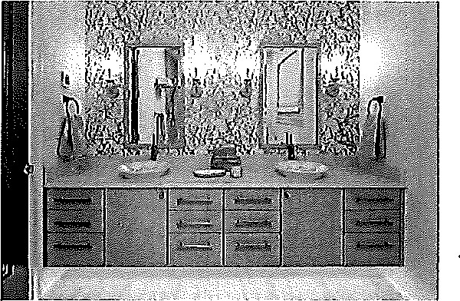

Glassware:
- Clean glasses shall be individually wrapped or fitted with a single-service cap that covers the edge of the glass.
- Reusable glassware and cups shall be returned to a dishwashing area approved by the Health Department. Glassware shall not be cleaned in the guest room.
- If a guest room contains a kitchenette with a domestic dish washer, kitchen ware assigned to the room can be washed in the dish washer.

Other:
- In general, all surfaces and equipment must be clean and in good repair (ex. fitness equipment, furniture, floors, walls, ceilings, light fixtures, curtains, water fountains, etc.).
- The interior and exterior of domestic food service equipment must be kept clean and in good repair (ex. coffeemakers, refrigerators, microwaves).
- Ice machines shall be kept clean and in good repair (interior ice formation area and ice dispensing shoots).
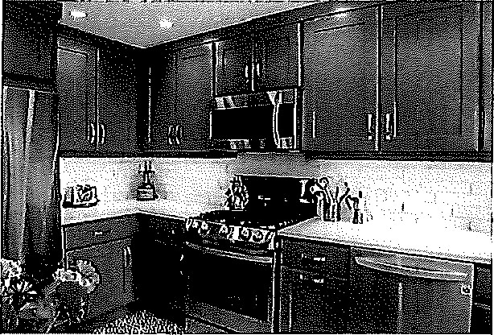
- Drain lines at ice machines shall not be directly plumbed to the floor drain, an air gap 1.5 times the diameter of the ice machine’s drain line shall be present.

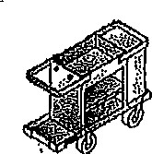
Cumberland County Department of Public Health

Housekeeping Cart Guide
- Store chemicals below or separate from linen and clean guest items. If separation is used, distance or a physical barrier must be used.
- Store personal items (drinks, phones, etc.) separate from linen and clean guest items.
- Store Linen in the center of the cart (See A in picture below)
- Store guest items on the top of the cart (See Bin picture). Examples of guest items: glassware, wrapped hand soap, bottled shampoo, etc.
- All used guest items.
- Store mops, brooms, sticky rollers, and other similar equipment so that the handle points toward the ceiling. (C is an example of improper storage)
- Store all trash in a trash bag.
- Store all soiled linen in a trash bag or separate container from clean linen and clean guest items.
- Clean the housekeeping cart daily.
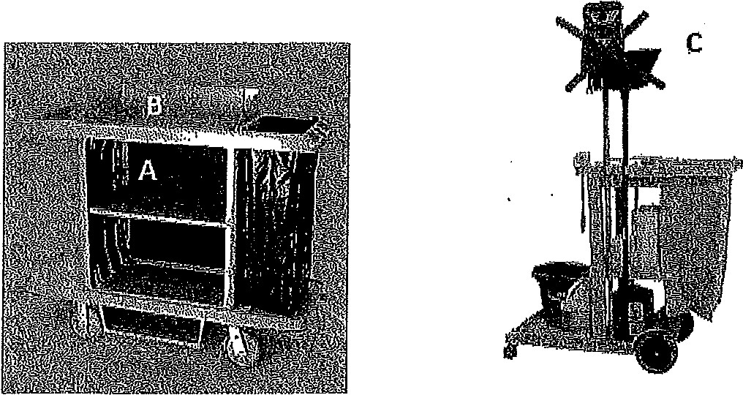
- Store unused cleaning cloths separate from clean linen and clean guest items.

QUESTIONS? CALL 910-433-3618

